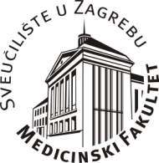
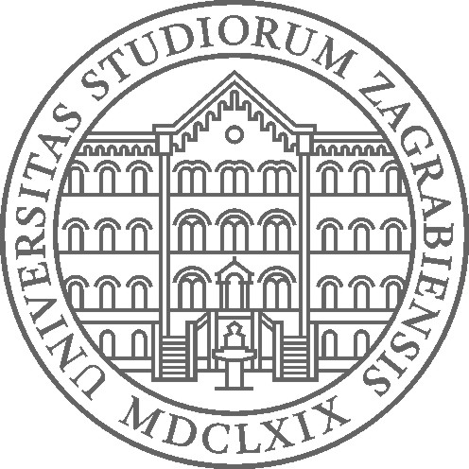

SVEUČILIŠTE U ZAGREBU
MEDICINSKI FAKULTET
CENTAR ZA ZDRAVSTVENU DJELATNOST
Voditeljica Programa unapređenja zdravstvene zaštite studenata
prof. dr. sc. Vesna Jureša, dr. med.

ZDRAVSTVENA ZAŠTITA STUDENATA
Polivalentno savjetovalište
Multidisciplinarna pomoć studentima

Dr. sc. Vera Musil, dr. med.
Dragan Soldo, dr. med.
Doc. dr. sc. Tea Vukušić Rukavina, dr. med.
Dr. sc. Marjeta Majer, dr. med.

ADRESA: Šalata 4 (prizemlje-lijevo), 10 000 Zagreb
RADNO VRIJEME (ponedjeljak - petak):
parni datumi – poslije podne: 13-17 sati
neparni datumi - ujutro: 8-12 sati
TELEFON (u radno vrijeme): 01 4590 297
E-mail: studamb@mef.hr
Napomena: na pregled ponijeti cijepnu iskaznicu i relevantnu medicinsku dokumentaciju.

SPECIFIC AND PREVENTIVE MEASURES OF HEALTH CARE FOR UNIVERSITY STUDENTS

Multidisciplinary Counseling Service

Vera Musil, MD, PhD
Dragan Soldo, MD
Associated Professor Tea Vukušić Rukavina, MD, PhD
Marjeta Majer, MD, PhD

ADDRESS: Šalata 4 (ground floor-left), 10 000 Zagreb
WORKING HOURS (Monday - Friday):
Even dates – afternoon: 1.00 p.m.-5.00 p.m.
Uneven dates – morning: 8.00 a.m.-12.00 a.m.
Phone (during working hours): 01 4590 297
Appointment booking: e-mail: studamb@mef.hr

Requirements for medical consultation: vaccination card and relevant medical documentation.

